Replica File Server Installation
Schindler CRD Applications

Exported on 2025-08-19 06:18:17

Table of Contents

1 Prerequisites: 4
2 Procedure: 5
2.1 Installation of Amazon Corretto 17.0.11.9.1 5
2.2 Download Installable: 9
2.3 Copy Master Key: 10
2.4 Installation: 13

- Prerequisites:
- Procedure:
  - Installation of Amazon Corretto 17.0.11.9.1
  - Download Installable:
  - Copy Master Key:
  - Installation:

Prerequisites:
- Need Admin access on Replica server.

Procedure:

Installation of Amazon Corretto 17.0.11.9.1
- Remove the below environmental variable on Replica Server (We are doing this as we are using existing replica to new Target QA Windchill).
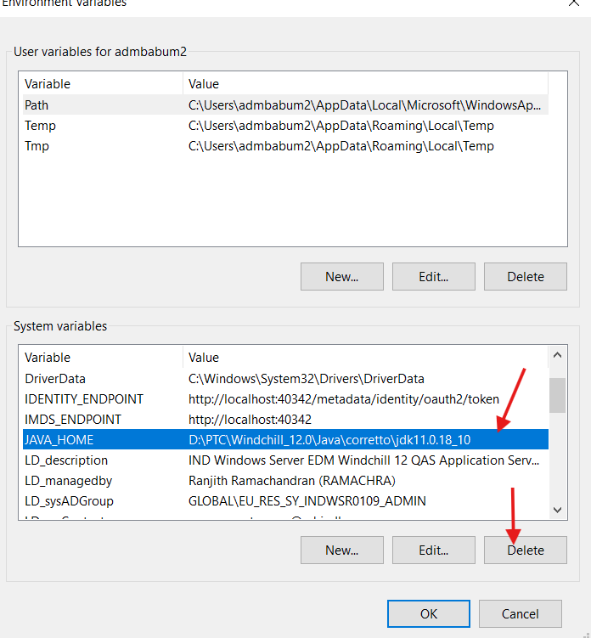

2. Also remove the environmental variable under path.
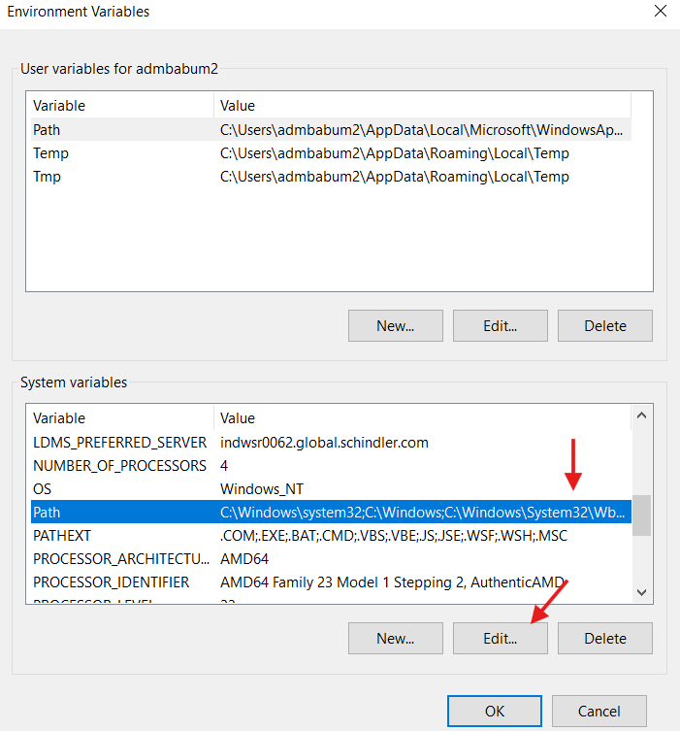

3. Select the below path and click on Delete.
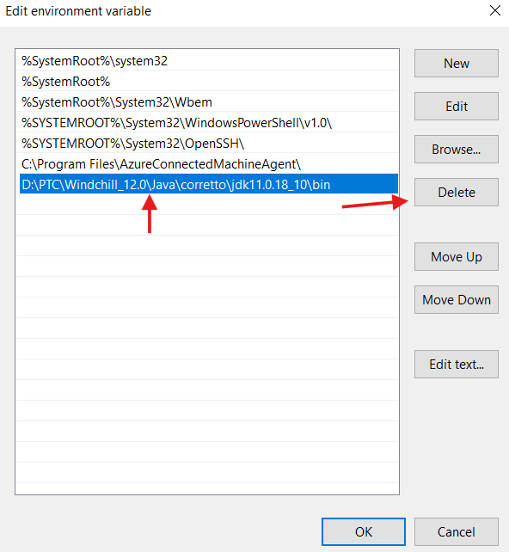

4. Click on Ok.
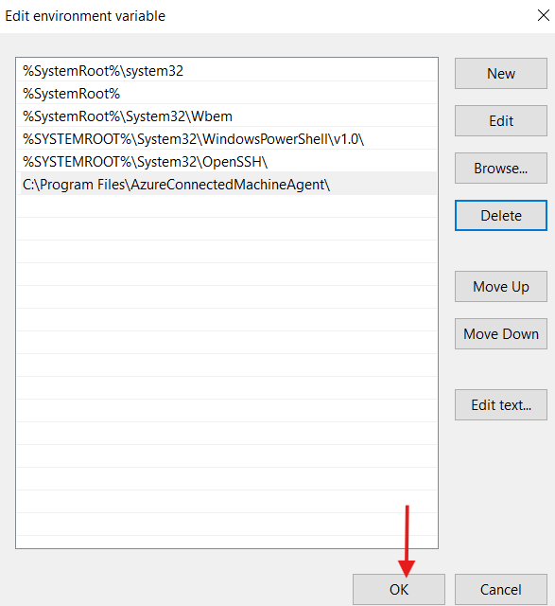
5. Download Amazon Corretto 17.0.11.9.1 using the below link.
Download Link: Release 17.0.11.9.1 · corretto/corretto-17 · GitHub
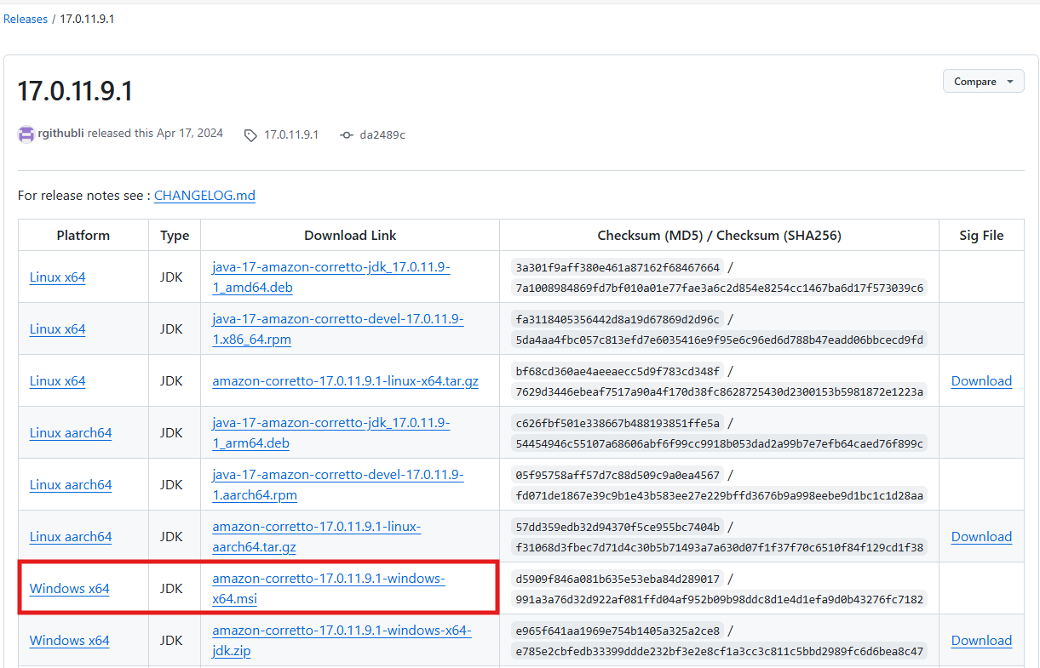

6. Extract the installable, right click and install as shown below.
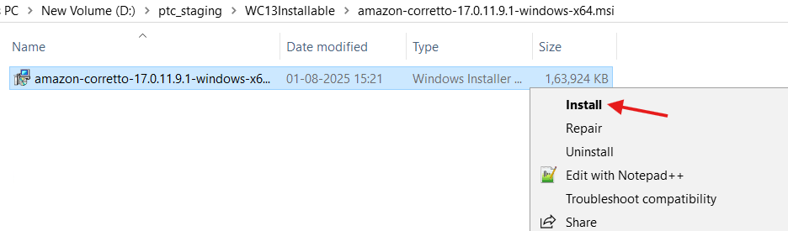

7. Click Next as shown below.
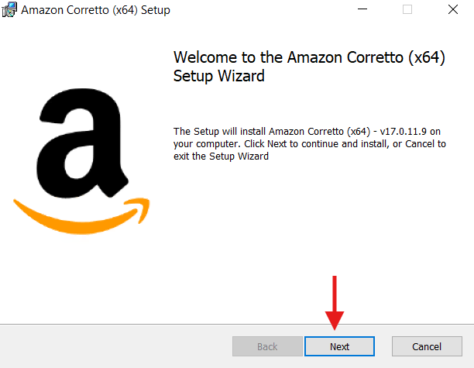

8. Browse the location as shown below and click on Next.
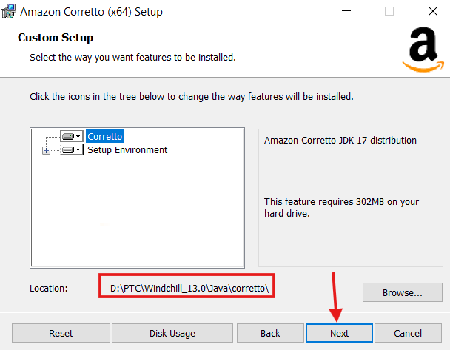

9. Click Install to begin the installation as shown below.
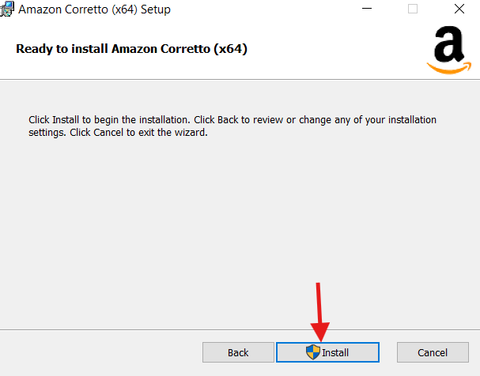

10. Click Finish button to complete the setup as shown below.
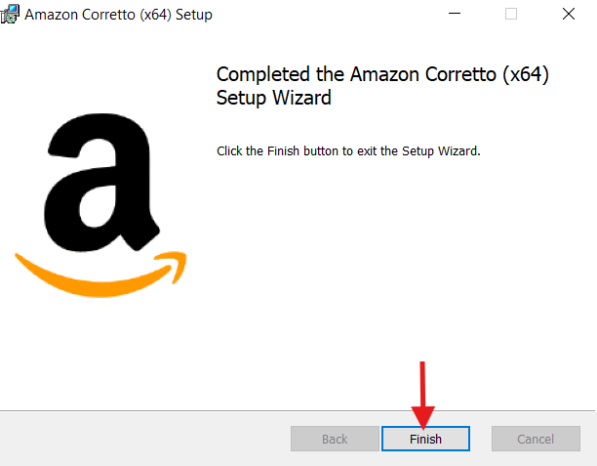

11. Please make sure the following environmental variables are in place after the installation.
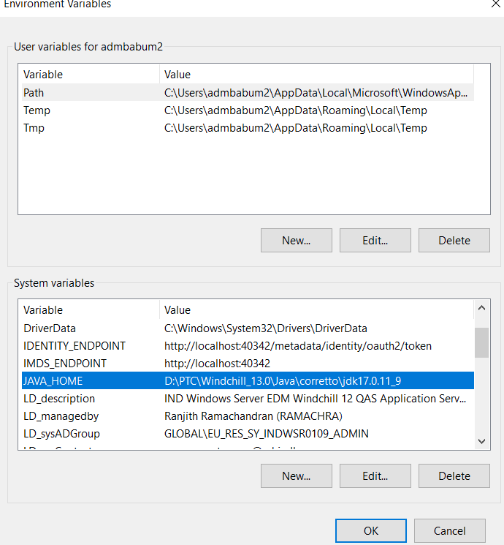

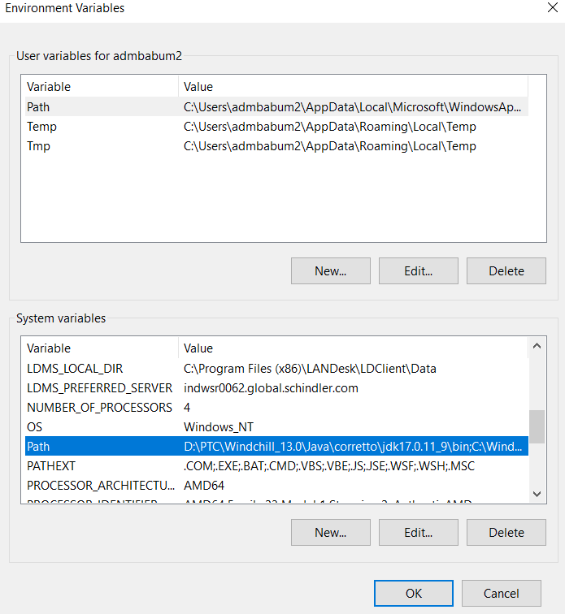

12. Restart the server.

Download Installable:
- Log into Windchill as an admin.
- Navigate to site → Utilities → File Server Administration.
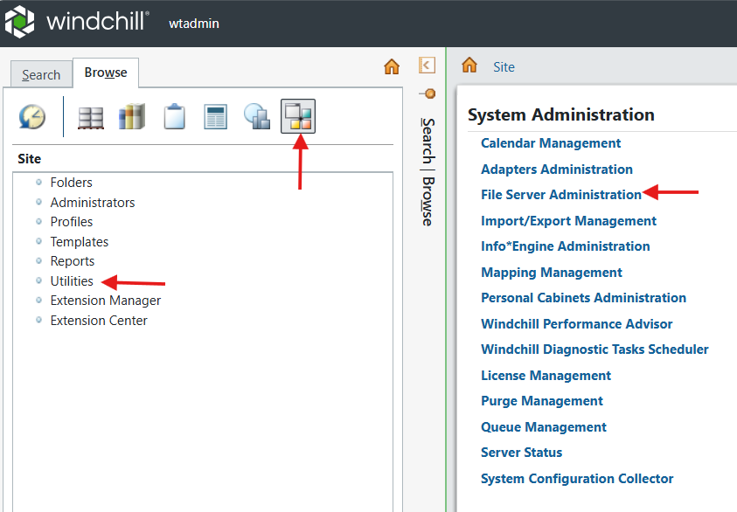

3. Click on File Server Management.
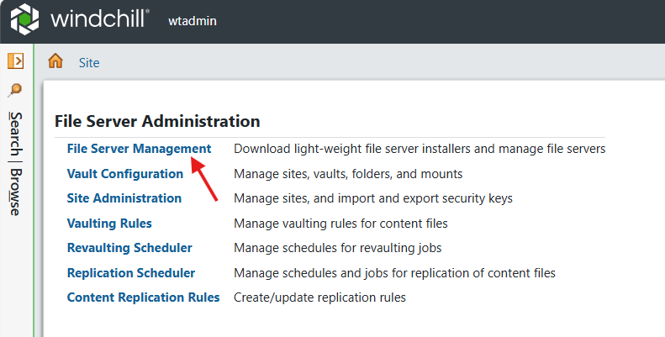

4. Download File Server Installer Bundle.
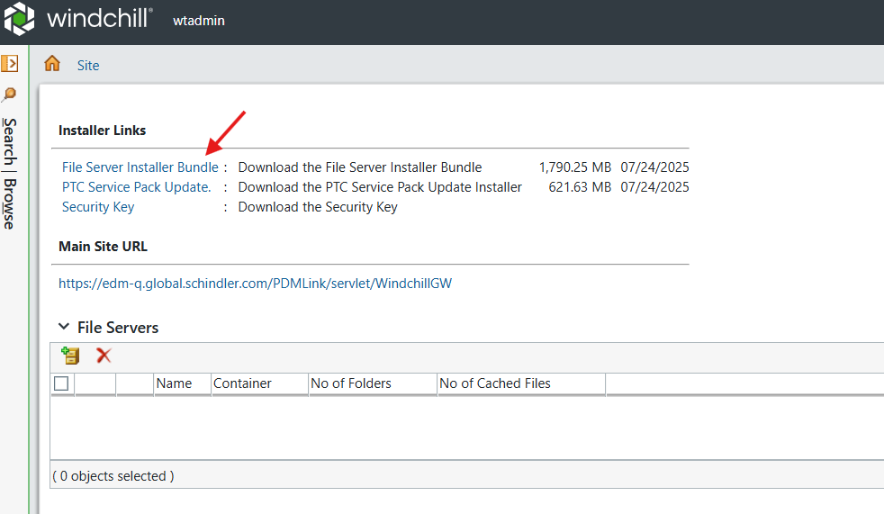

5. Copy the installable to the Replica Server.

Copy Master Key:
- Log into Windchill as an admin.
- Navigate to Site → Utilities → File Server Administration.

3. Click on Site Administration.
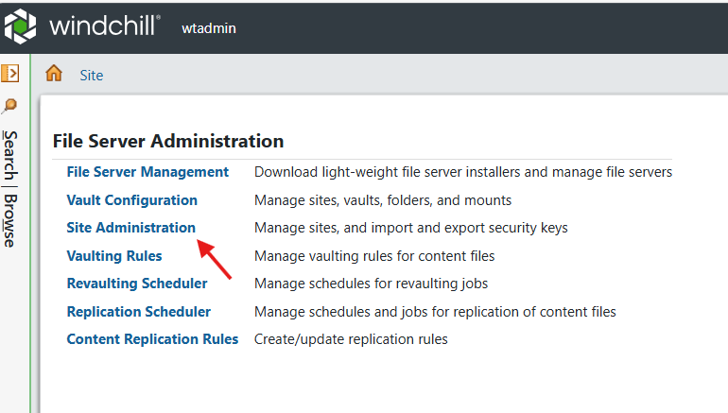

4. Select the entry as shown below and click on Edit.
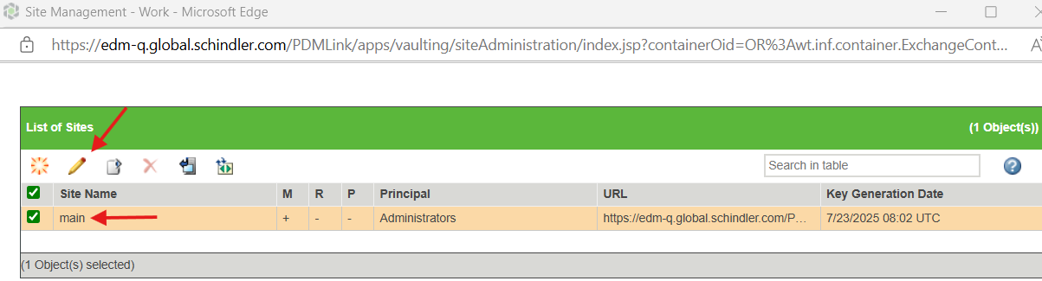

5. Provide the value as master and click on Ok.
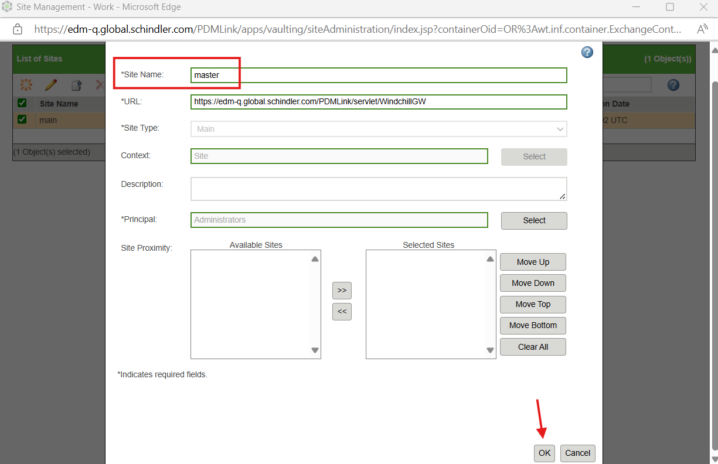

6. Select the entry and click on Export.
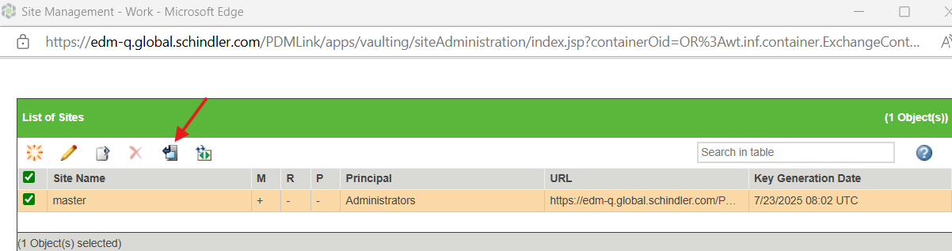

7. The file will be exported as shown below.

8. Rename the existing master.pubkey as shown below.
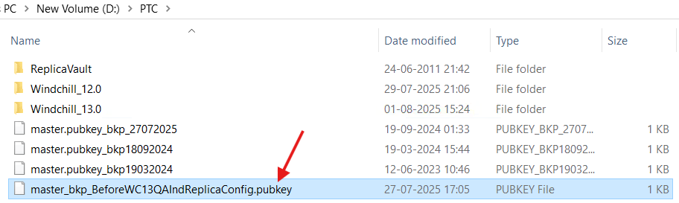

9. Copy and paste the extracted latest master.pubkey under PTC folder as shown below.
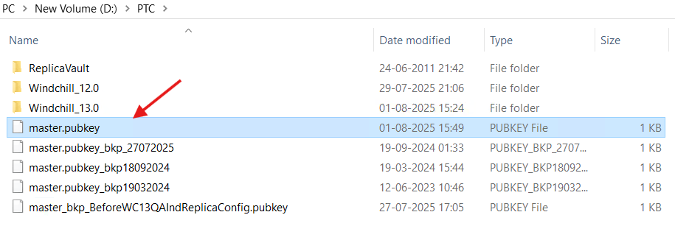

Installation:
- Extract the downloaded (File Server Installer Bundle) installable CcsInstallerBundle.zip
- Launch cmd as administrator and navigate to the PSI of the installable as below and execute setup.vbs
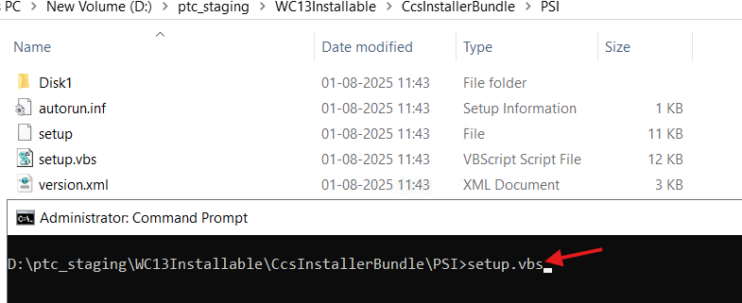

3. Click on Ok.
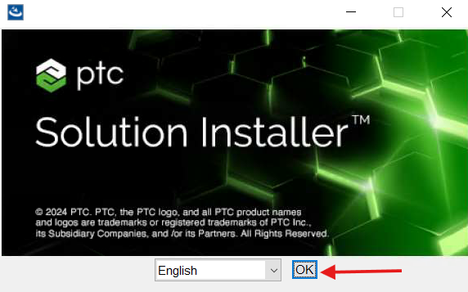

4. Click on Next.
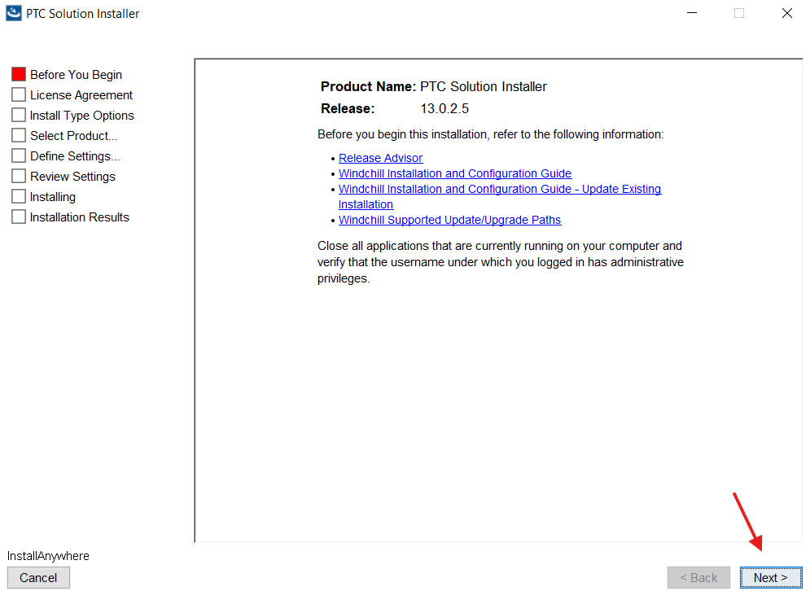

5. Select "I accept" and click on Next.
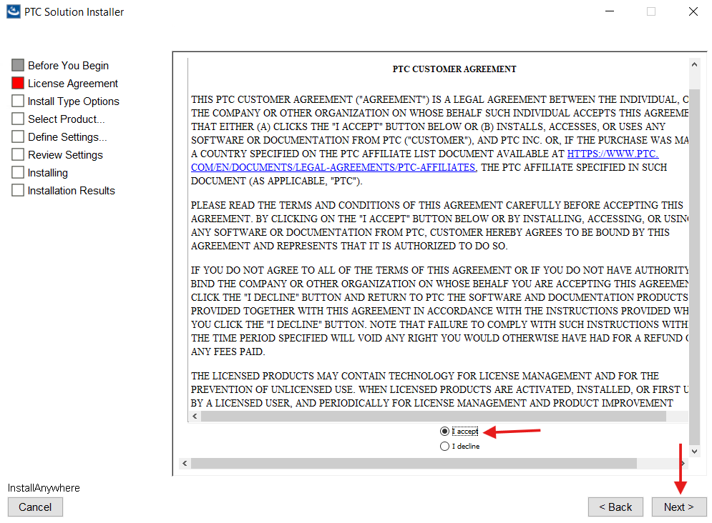

6. Select the checkbox and click on Next.
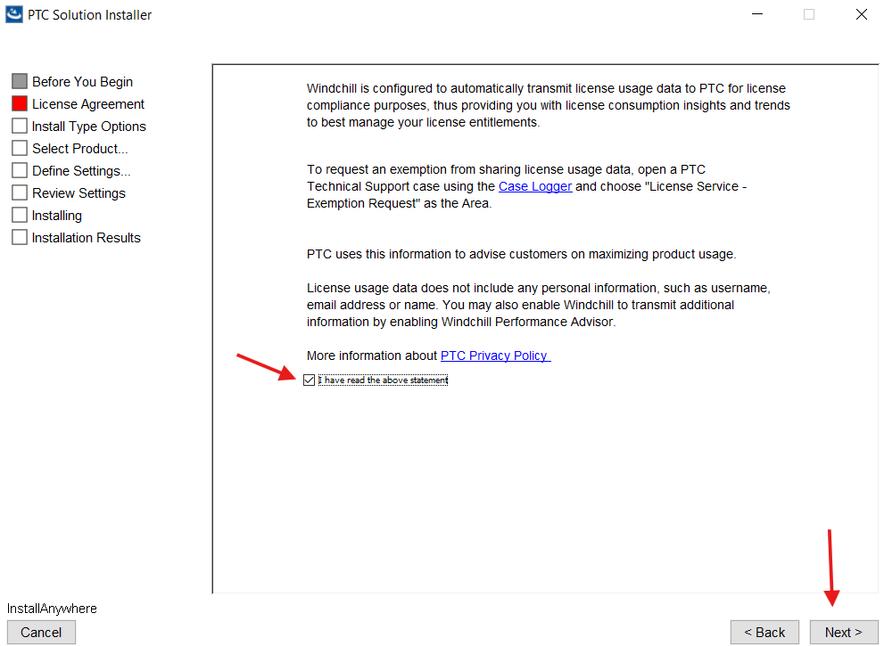

7. Select 'New Product Installation' and click on Next.
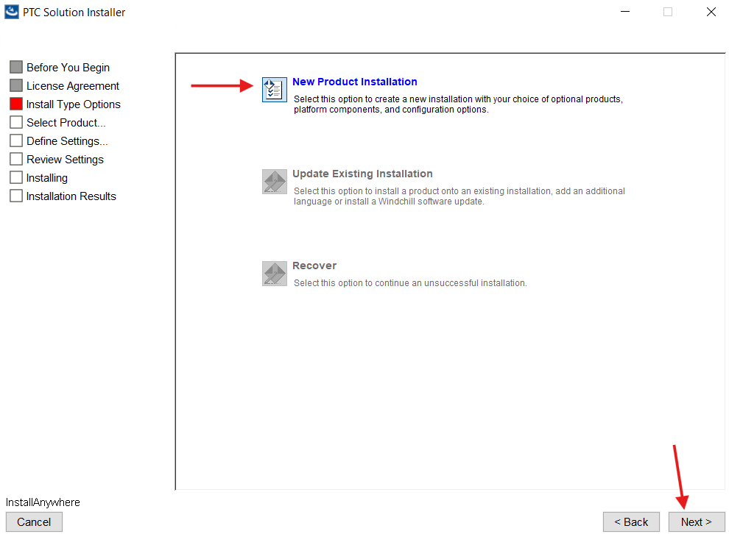

8. Select "File Server" under Remote File Server section and click on Next.
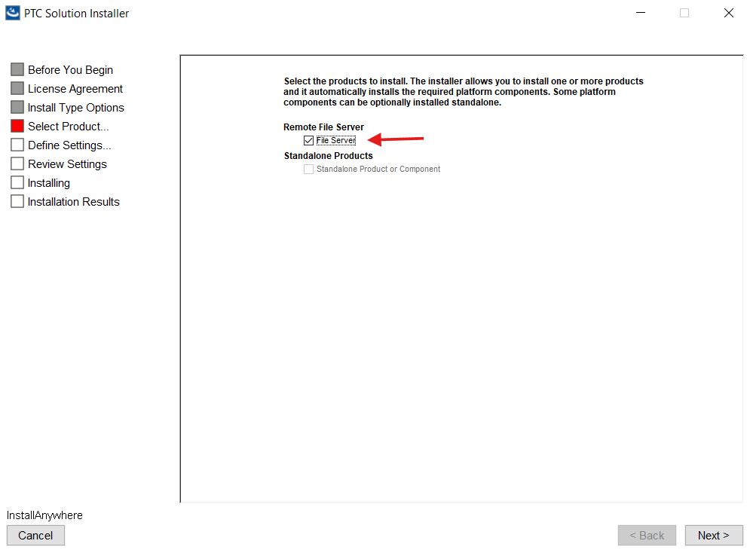

9. Click on Next.
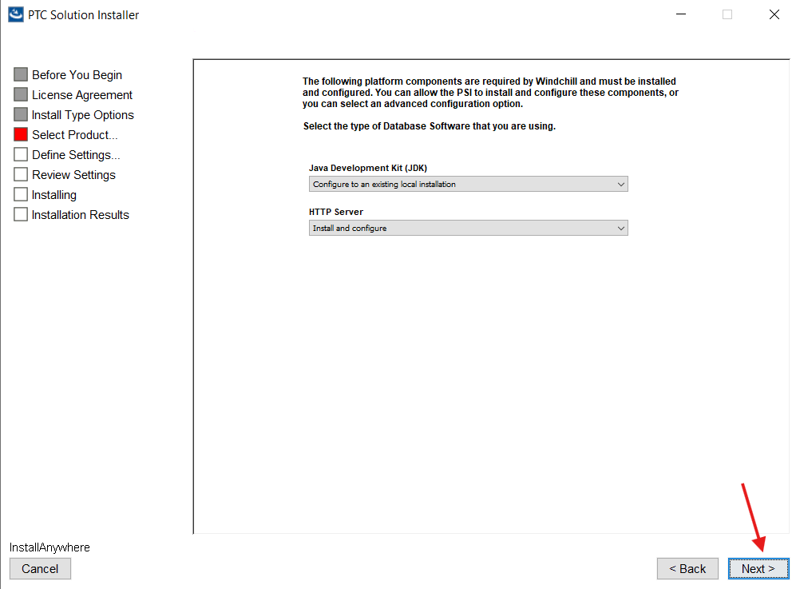

10. Click on Next.
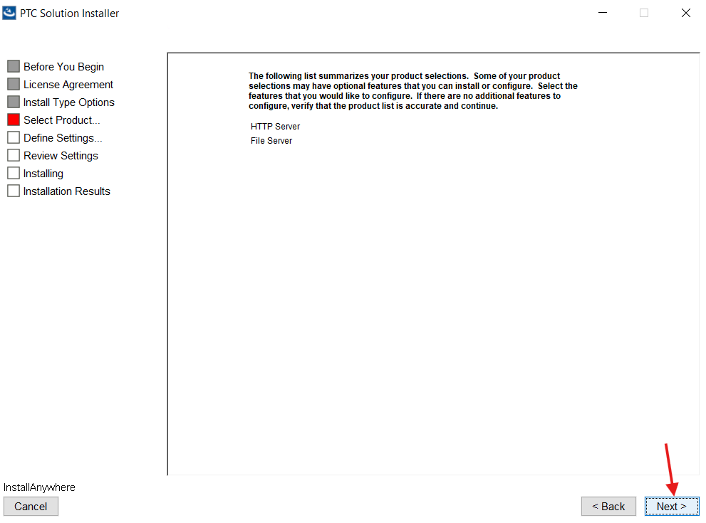

11. Provide the installation name and Click on Next.
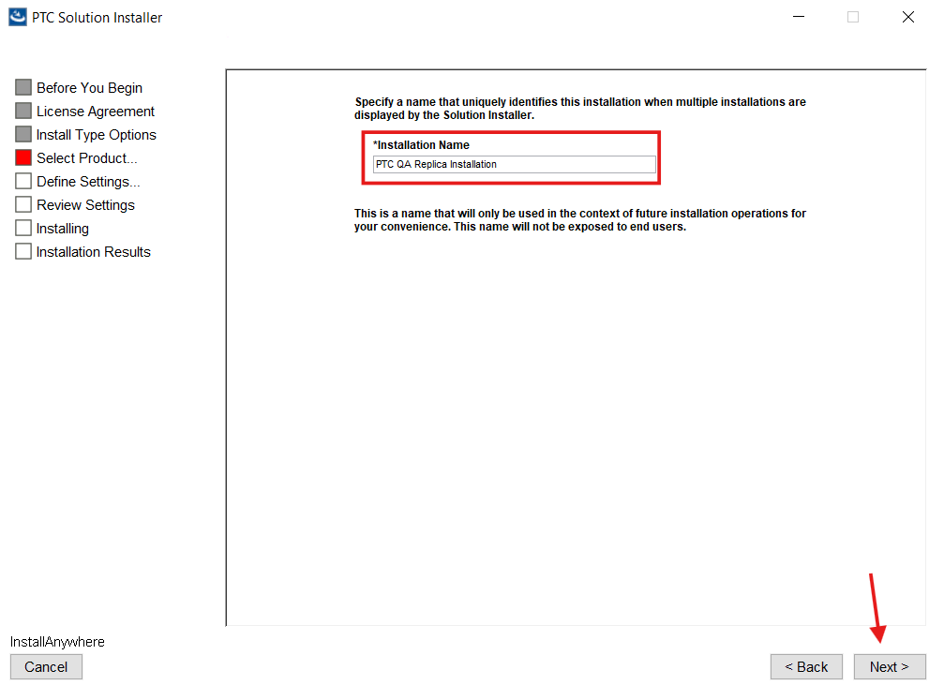

12. Provide the installation directory as shown below and click on Next.
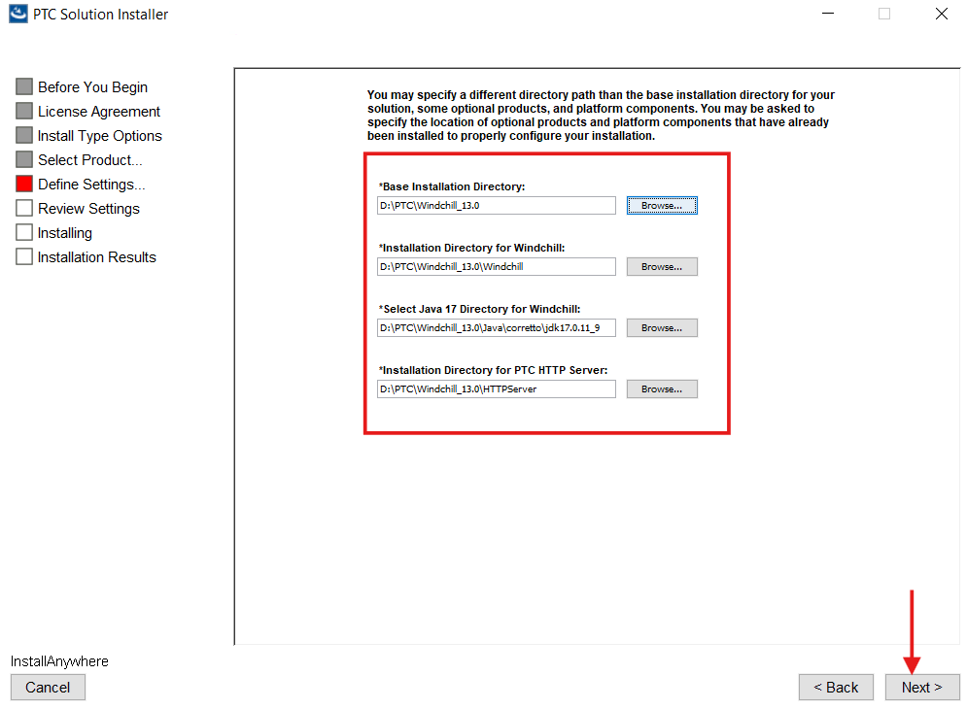

13. Click on Next.
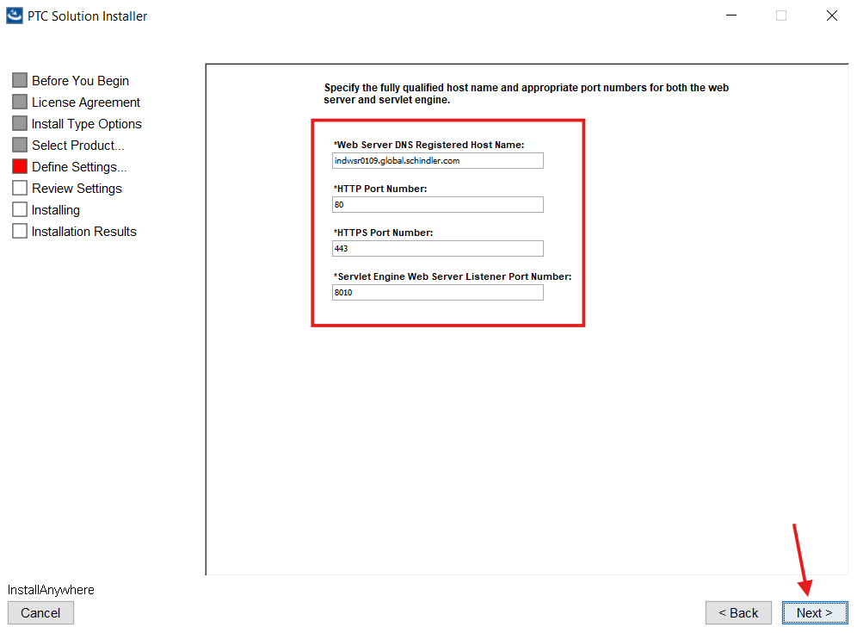

14. Log into Windchill as admin and navigate to Site → Utilities → File Server Administration.

15. Click on File Server Management.
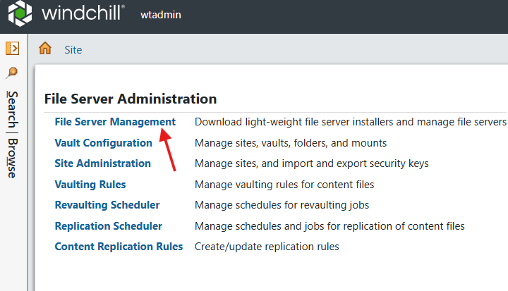

16. Copy the Main Site URL.
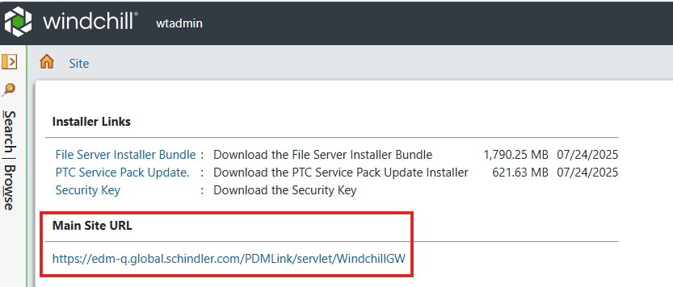

17. Provide the values as shown below and click on Next.
Web Application Context Root: PDMLink
Info*Engine Server Task Processor Port Number: 10002
Main Site Gateway URL: https://edm-q.global.schindler.com/PDMLink/servlet/WindchillGW
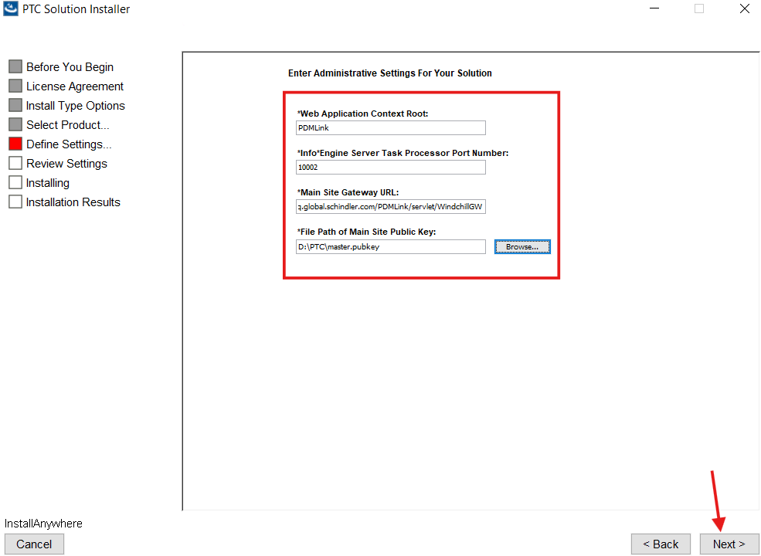

18. Select the checkbox as shown below and click on Next.
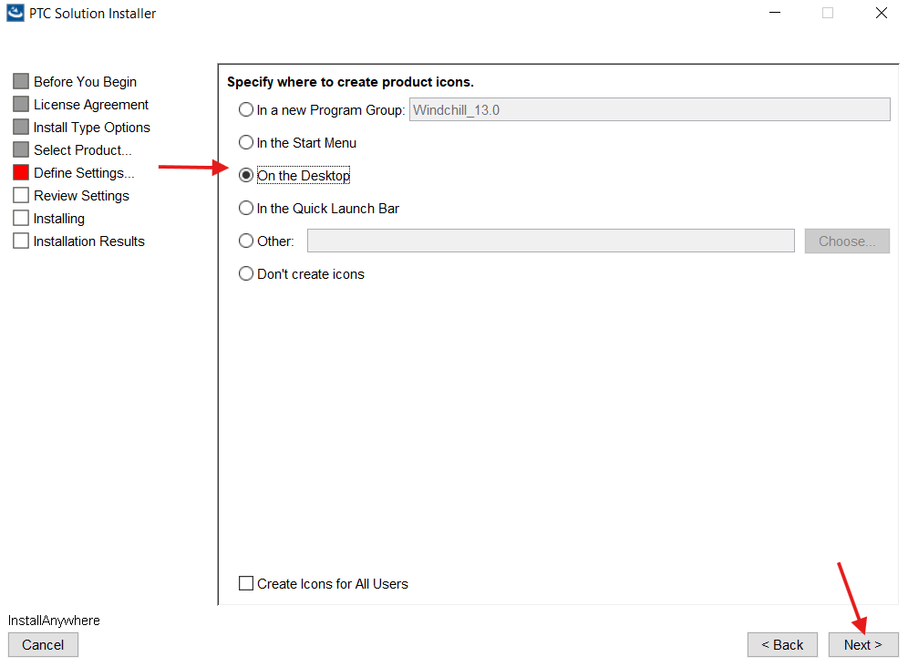

19. Click Next.
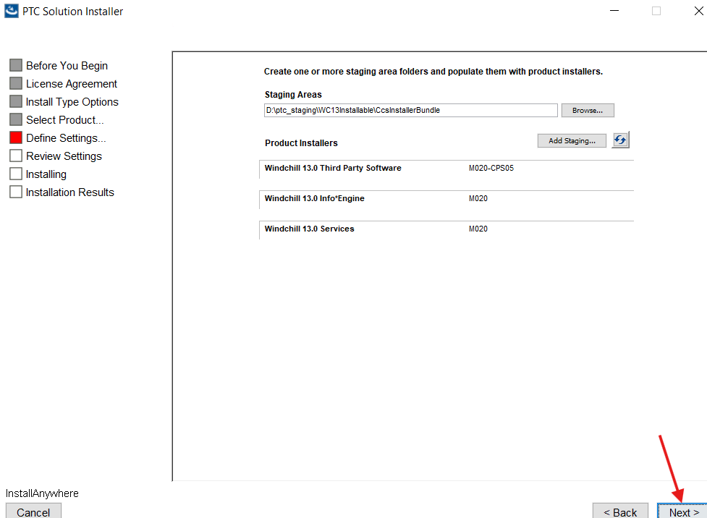

20. Review the details and click on Install.
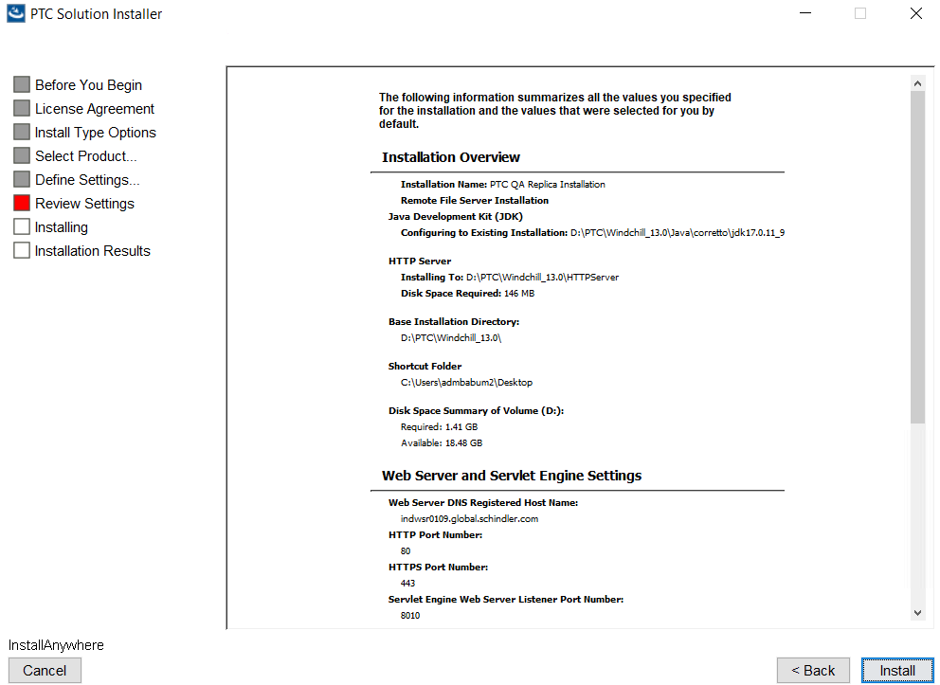
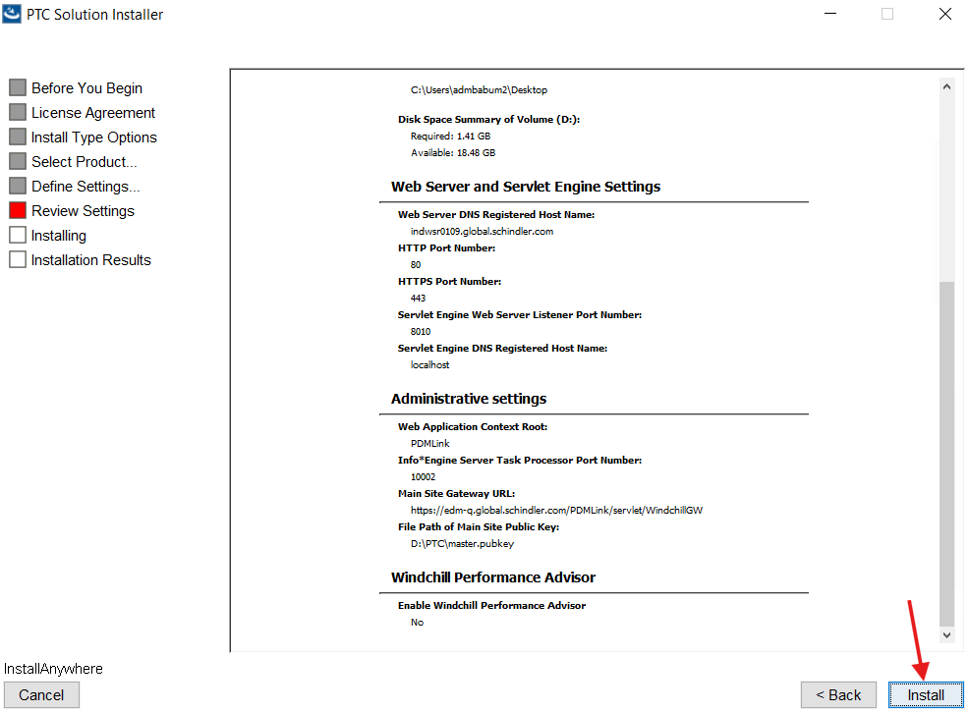

21. Click on Done.
